2007 Third Professional Year Project

Multiple Channel Datalogger

Adrian Gin

Supervisor: Hamish Laird
Abstract

This report describes the design of a fully differential multiple channel datalogger. A maximum capacity of 32 channels can be achieved using expansion cards. Based around an ATMEGA32 microcontroller, the datalogger is capable of measuring voltage signals up to a maximum of 60V differential, and can measure temperature directly from thermocouples. With the use of transducer interface circuits, a multitude of environmental variables can be logged.

Large dynamic range is achieved using a variable gain instrumentation amplifier with a 22-bit Sigma Delta ADC. The maximum sample rate is 10 milliseconds and precision is within 0.05%. Data is recorded onto a SD memory card and the recordings can be downloaded via a USB connection to a PC.

INTRODUCTION

Measurements play an important role in the current world today. Measurements aid in decision making, provide information for assessments and aid in the understanding of a system or environment. Measuring devices can be found all around us; the common car has hundreds of sensors ranging from the accelerator pedal, tyre pressure, airbag, wheel speed, motor speed and temperature sensors.

Dataloggers are devices which are capable of recording measurements over a certain period. They have many applications and can be used to establish relationships between several variables or to map trends in environmental conditions. The aim of this project is to design and build a multiple channel datalogger.

Dataloggers tend to measure signals which vary slowly over time, and have time constants in the order of seconds to minutes. This is in contrast to a data acquisition system whose sampling rates are in the order of several hundred kilo-samples per second. Dataloggers are suited to measuring temperature for example, where sampling at a high rate would be misleading because of the thermal time constants associated with the temperature sensor.

The majority of transducers output very small signals or variations and cannot be directly measured with digital equipment. The signals need to be amplified and conditioned to maximise noise rejection before being read by an analogue to digital converter (ADC). For example a K-type thermocouple produces only 40μV per degree Celsius; this requires a low noise amplifier to increase the signal amplitude before it may be read by an ADC.

Dataloggers usually run off batteries and need to have very low battery power consumption. It is not uncommon for dataloggers to be left unattended capturing data for days or weeks on end. The medium on which the data is stored, as well as how the data is retrieved are other major design considerations.

The following section will briefly discuss some aspects of project management, followed by general theory of datalogger design. The bulk of this report will discuss the design process and considerations for the hardware and software components of the datalogger. Issues facing current dataloggers will also be addressed. These include, low battery power consumption, high accuracy and resolution, fast sampling rates and efficient methods of data storage and retrieval. The report will conclude with an evaluation of datalogger design and performance.

Circuit diagrams and printed circuit board layouts can be found in the appendix.

PROJECT MANAGEMENT

At the onset of this project, a timeline (Figure 1) was devised which provided an indication of the sequence of events and milestones. The most important aspect of this process is to allocate available time and set goals to ensure deadlines and milestones are met. Dependencies were also highlighted, for example, printed circuit board (PCB) design and construction could only take place once circuit design had been finalised.

The next step in the project was to discover the scope and requirements for the datalogger. This was done with several meetings with the project supervisor. Once established, research was done into different datalogger designs. The aim of this was to find typical datalogger features and high level block diagrams for the basic design.

High level designs were then produced, and each functional block would be split into smaller components. Further research would then commence focusing on each component until a circuit design could be realised.

Although not explicitly depicted, for successful construction of the PCB, circuit design needed to take into account component lead times, availability and cost. There were numerous situations where designs needed to change because a preferred component was too expensive or could not be ordered. A cost breakdown and component listing can be found in Appendix C.

The timeline was a running document, and reflected the actual sequence of events prior to the current date. Durations and sequences of events after the current date were estimations. Previous timelines were compared with the running document to gauge progress and to predict the possibility of potential problems in the future.

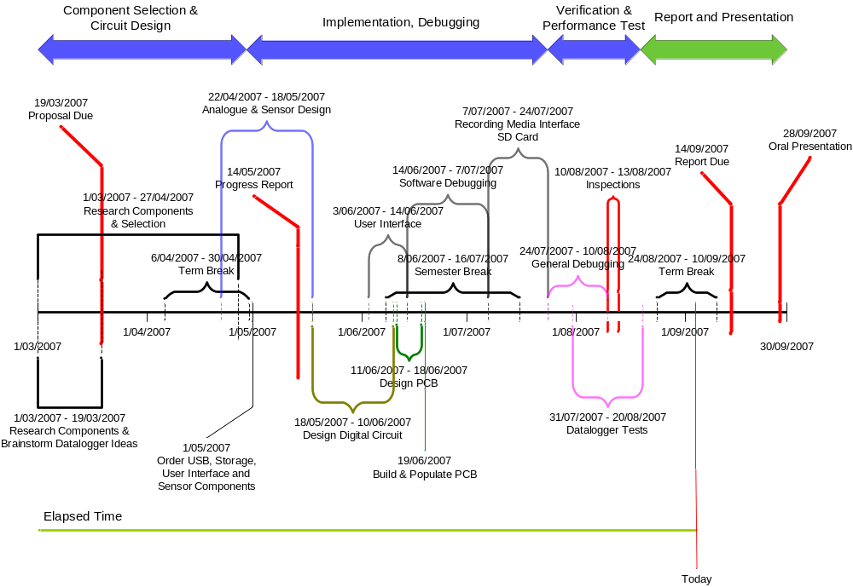
Figure 1 Project Timeline as at 3rd September 2007

THEORY OF OPERATION

This section will describe the theory of operation behind each of the major components of a datalogger. A functional block diagram of a typical datalogger is shown in Figure 2.

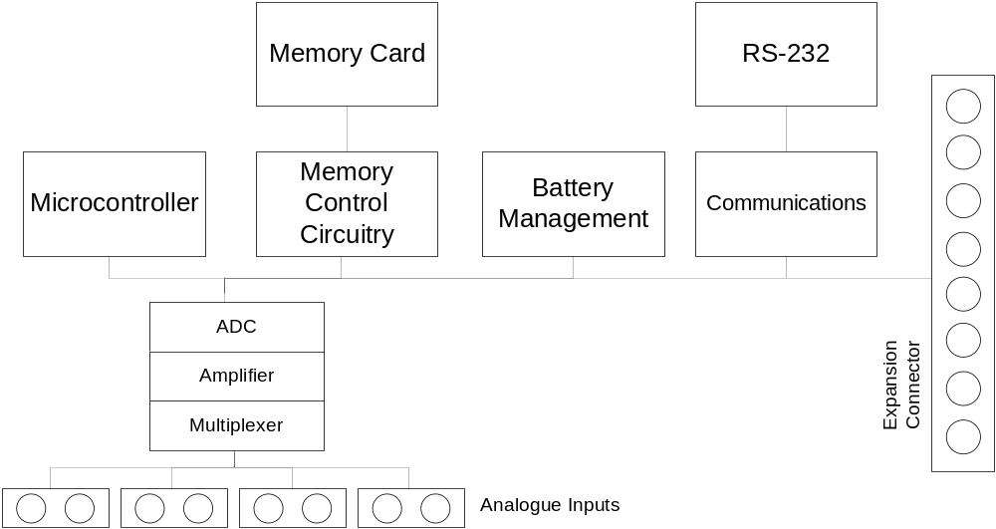

Figure 2 Typical functional block diagram for a datalogger [,]

Signal Conditioning

Although fundamentally limited to measuring voltages, dataloggers can measure a vast range of environment variables through the use of transducers. The two main types of transducers are passive and active. Passive transducers require some sort of electrical excitation to produce an output, whereas active transducers do not. Examples of passive transducers are thermistors and resistor temperature detectors (RTDs). A thermocouple produces its own voltage potential and is an example of an active transducer [].

A low noise amplifier (LNA) is required since both active and passive transducers typically produce very small variations in their output signal. Furthermore this signal is usually very high impedance, meaning very little signal power can be extracted. A well designed amplifier may suppress noise and amplify the useful part of the signal allowing subsequent signal conditioning to take place [Error: Reference source not found].

In some cases, a transducer interface board may be connected to a datalogger input. This interface board will most likely have onboard amplification and output a standardised output signal such as 0-5V or 4-20mA [Error: Reference source not found]. However increased costs will be the main drawback for this simplified transducer interface.

For a datalogger, it is not economical to assign each input its own dedicated set of amplifier and ADC module. Instead, multiple inputs are multiplexed to one channel allowing one amplifier and ADC module to measure all inputs [Error: Reference source not found].

Memory Management

Recorded data must be written to memory which does not lose its contents once its power supply has been removed, this type of memory is known as non-volatile (NV) memory. This is usually in the form of ‘Flash’ memory or Electrically Erasable Programmable Read Only Memory (EEPROM). However recent developments in memory have allowed large volumes of data to be stored on physically small devices known as memory cards. These memory cards are non-volatile and can be exchanged for a blank card while in the field, easing data retrieval and minimising the disturbance in the measuring environment [Error: Reference source not found].

Battery Management

Dataloggers usually operate off batteries because there will be many situations when a datalogger will be used where there is no readily available power supply. If the datalogger is to record measurements for an extended period, it is important that battery power be conserved. Battery management involves shutting down sections of the datalogger which are not in use. For example, shutting down the ADC, memory card, microcontroller and the communications circuitry during lengthy sample intervals may reduce current draw.

Communications

A communications interface to the datalogger is required to retrieve logged data. There are several efficient methods which include: Universal Serial Bus (USB), FireWire, RS-232, RS-485 or Ethernet. In some cases, Infrared Data Association (IrDA), Bluetooth, Global System for Mobile communication (GSM) or a radio modem could be used where wireless contact is preferred. The most suitable interface will be based on the required transmission distance, transfer speeds, security measures and cost [Error: Reference source not found].

Microcontroller

The microcontroller co-ordinates the flow of data between each module and controls the timings of certain actions. Microcontrollers are programmable and allow many features to be implemented in software. This reduces the cost and complexity of the hardware by combining a lot of functionality in one chip. Due to the relative ease of programming a microcontroller, a lot of functionality can be implemented in a short space of time, thereby decreasing development time.

Expansion Connector

An expansion connector allows for increased input channel capacity, and depending on the complexity of the expansion modules, may provide extra channels at a reduced cost without incurring the overheads of another datalogger board [Error: Reference source not found].

HARDWARE DESIGN

Three major components of the datalogger are the sensors, user-interface and data storage circuitry. Figure 3 shows the composition of these main components. This section will explain the design process for the hardware, and focus on the datalogger’s main sub-components.

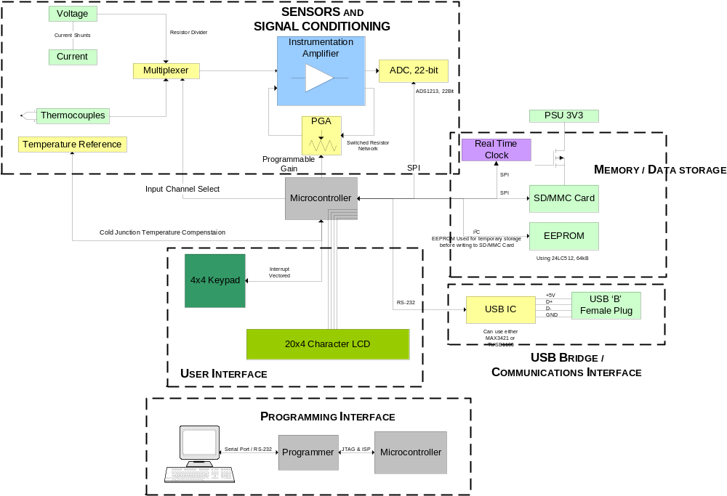

Figure 3 Datalogger Hardware Design

Sensor Input Design

Voltages from K type thermocouples will be the smallest signal that this datalogger will be designed to measure. K-type thermocouples output approximately 40μV per degree Celsius and have very high output impedance []. To measure such small voltages accurately, the sensor input circuit (Figure 4) is designed so that the signal is not heavily loaded and that electrical noise is rejected.

Each input channel is physically configured to measure either voltages or thermocouple inputs. The only difference is that resistors R44 and R45 are loaded on the voltage inputs. Although this reduces the signal to noise ratio (SNR), it allows differential voltages up to 60V to be measured. Caution must be taken not to exceed more than 5V common mode voltage between the thermocouple inputs.

The input impedance of the datalogger is very high and this will mean the signal will not be affected by the connection of the datalogger []. Most signals will be relatively high impedance, and to minimise the disturbance due to the interconnection, input resistors of 2.7MΩ were chosen. This is considered relatively high as common digital multi-meters and oscilloscopes have input impedances of only 1MΩ.

To minimise the input noise, the bandwidth is reduced via a first stage low pass filter created by the input resistors and capacitors C35 and C36. The resistors, R46 and R47 bias the signal around the virtual ground as well as provide the necessary bias currents for the op-amps.

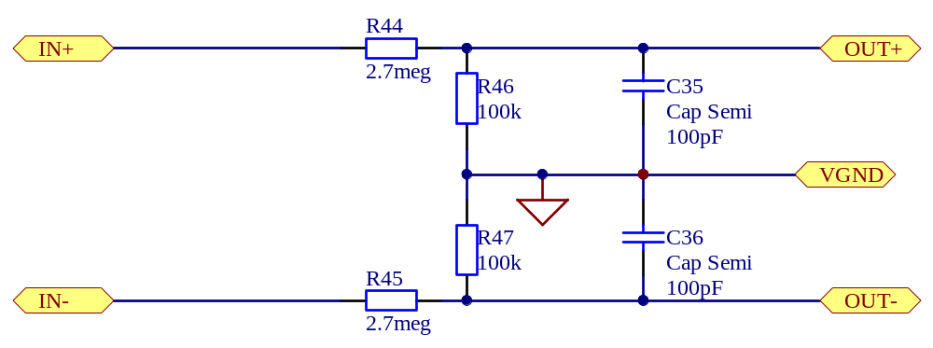
Differential Sensor Input
To Multiplexer
Figure 4 Sensor input circuit for one channel

Two Stage Multiplexer

A modular sensor input front-end allows up to eight sensor cards to be connected. The two stage multiplexer circuit diagram can be found in Figure A-18 and Figure A-19 in Appendix A.

Each sensor card connects to one of the expansion slots and provides four differential channels. With all eight expansion slots utilised, up to 32 fully differential channels can be used to obtain data. Each channel is multiplexed into the differential amplifier and subsequent signal conditioning circuitry. A differential measurement system was chosen over a single ended system as common mode noise will be largely rejected.

Signal Conditioning

The primary input gain stage is comprised of three operational amplifiers (op-amps) connected in an instrumentation amplifier configuration (Figure 5). This configuration was chosen because it has very high input impedance and common-mode rejection []. These two factors allow voltage signals from thermocouples to be amplified accurately and subsequently read by an ADC.

A voltage supply of 5V was chosen for the analogue circuitry. This could conveniently be supplied by four AA batteries. However, traditional op-amps run off dual polarity supplies allowing signals varying either side of ground to be amplified. An amplifier based around a single sided battery supply is more complicated to design, and require signals to be biased about a virtual ground or reference voltage [Error: Reference source not found]. The virtual ground is at a potential of 2.5V allowing positive and negative signals to be equally amplified. Rail to rail op-amps were chosen to maximise dynamic range, this essentially increases maximum output swing without the signal clipping or distorting [].

Voltages being placed at the sensor input will most likely need to be reduced or amplified before being passed to the ADC. Having variable gain is one way to condition the signal and utilise the maximum input range of the ADC [Error: Reference source not found,]. Variable gain is achieved by switched resistor networks in place of the gain resistors in the instrumentation amplifier (R48, R49, R54, R55, R56, R61 - R63). Ten different gain settings have been calibrated which provide gains ranging from 0.04 to 270 V/V.

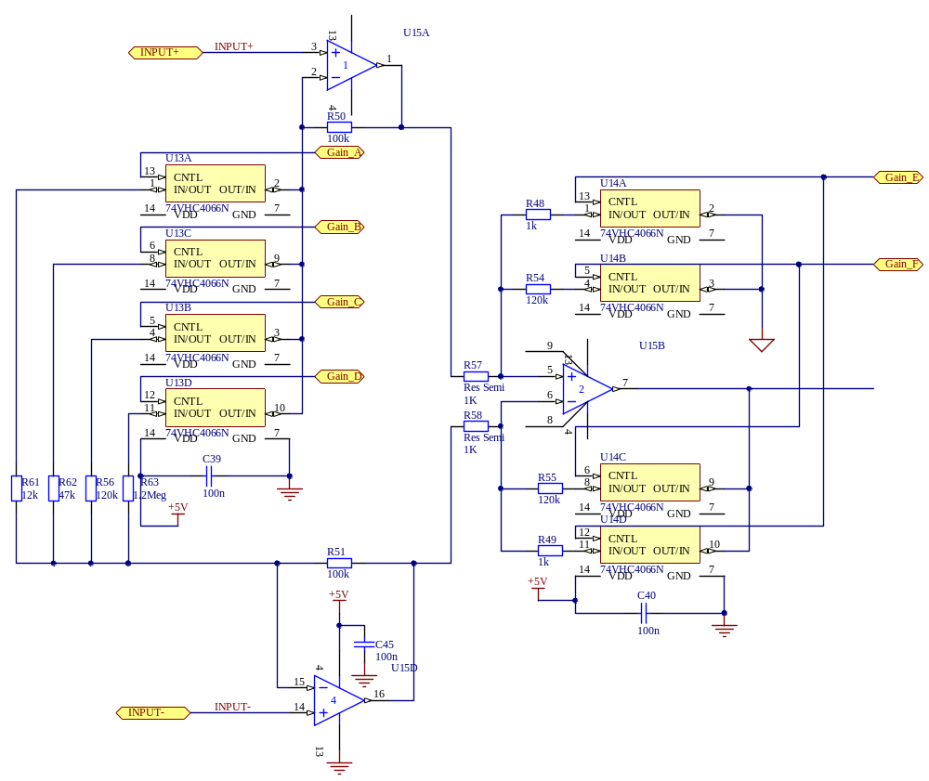
Figure 5 Variable gain instrumentation amplifier

By oversampling the signal, a lower order analogue anti-aliasing filter can be used, thereby reducing costs and circuit complexity. Noise is also reduced, increasing the resolution of the analogue to digital conversion [Error: Reference source not found]. Oversampling is also discussed in the following sub-section.

An active voltage controlled voltage source (VCVS) 2nd order low pass Bessel anti-aliasing filter was placed to reduce the noise and increase the resolution of the AD conversion. The Bessel polynomial was chosen for its linear phase response []. The cut-off frequency was designed for 1 kHz to introduce an oversampling factor of 12.5. Since the oversampling technique was employed, a simple 2nd order filter was sufficient.

Analogue to Digital Conversion

There are many types of ADCs including Successive Approximation Register (SAR), Dual Slope, Sigma Delta and Flash. Each type of ADC has different qualities ranging from conversion times, resolution and cost. SAR and Sigma Delta ADCs offer the most economical choice when conversion speed and resolution are most important []. A Sigma Delta ADC was chosen over a SAR because of its higher resolution and provision for on-chip digital filtering. This feature meant post conversion digital filtering would not have to be done by the microcontroller.

A 22-bit Sigma Delta Burr-Brown ADC (ADS1213) was used to digitise the analogue signals. Data is read out of the ADC serially into the main microcontroller. The maximum output data rate of the ADS1213 was configured to 12.5 kHz. An oversampling factor of 12.5 meant that frequencies up to around 1 kHz could be accurately recorded. By oversampling, the Nyquist-Shannon theorem is satisfied, which states that the sampling rate needs to be at least twice that of the largest frequency of interest [Error: Reference source not found].

Memory and Data Storage Design

Major considerations when determining the medium on which data is stored include, price, access (read and write) times, physical size, power consumption and data capacity. Secure Digital (SD) card was the chosen medium over other recordable media such as compact flash (CF), floppy disk and hard disk drive. This was because SD cards have reduced physical size, power consumption and pin count over other types. SD cards may also be exchanged for a blank card while in the field simplifying the method of data transfer and retrieval.

Despite EEPROM being relatively easy to interface with, SD cards are more cost effective, have faster write times and higher write cycle endurance []. Provision was made however for writing to an EEPROM chip because of the significant cost of an SD card.

Once data is written to either the EEPROM or SD card, data may then be retrieved via the USB connection or by removing the SD card, and placing it into an SD Card reader connected to a PC.

User and Communications Interface Design

A keypad and LCD display allow the user to adjust various datalogger settings. These include the ability to adjust the sampling rate and channel status (on/off, voltage/temperature). The datalogger connects to a PC via a USB connection. USB was chosen over a standard RS-232 connection because of increased speed and increased availability of USB ports among modern PCs [, ].

The primary use of the USB connection is to allow the user to download recorded datasets. Data is transferred at a maximum rate of 1 megabit (Mbit) meaning a 10 megabyte dataset can be downloaded in 80 seconds. This connection also allows various hardware commands to be sent to the microcontroller and provides diagnostics to determine any hardware faults.

Microcontroller

Four different brands of microcontrollers were considered, these were: Microchip’s dsPIC and PIC18F series, ARM based, Texas Instruments’ MSP430 series and Atmel’s AVR line. These devices were all capable of performing the required functions, and the selection was based upon the device whose software could be developed quickest and most efficient. Table 1 shows a brief comparison among the devices.

Table 1 Advantages and Disadvantages among different microcontrollers
Microcontroller | Advantages | Disadvantages
dsPIC; PIC18F | On board DSP unit | Limited software building utilities
ARM | High speed | High power consumption
MSP430 | Low Power consumption
AVR | Good software building tools  Familiarity with devices | Relatively slow

The ATMEGA32L was chosen as the main microcontroller, based on the familiarity with the AVR series and the accompanying software building tools.

Battery Management

To minimise battery power consumption, switch mode power supplies were used rather than linear voltage regulators. The circuit in Figure 6 provides +5V from a four AA battery pack, and a similar circuit provides +3.3V for the digital hardware. Components such as the memory card, ADC and microcontroller were placed into standby or sleep mode when they were not being used. This maximised battery life allowing the datalogger to operate in the field for a longer period.

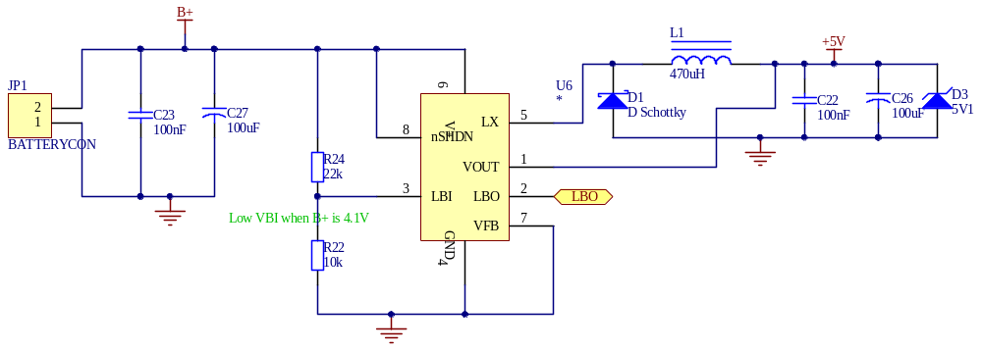
Figure 6 Switch Mode Power Supply circuit

SOFTWARE DESIGN

Software was designed with continual development in mind. This meant that software development processes needed to be used. Automated document and source control are such processes which were employed to aid future development.

‘Doxygen’ provided a way to keep track of documentation and could also present each software module in a PDF or HTML document. This would display the comments and usage associated with each function and variable, thus helping developers understand the code.

‘Subversion’ (SVN) was used to keep a working and an up to date copy of the code. Subversion works by having a ‘code repository’ which is continually updated and backed-up after each code revision. SVN allows code to be reverted to an older, previous revision if the current version becomes unstable with bugs. The code repository is located at: http://avr-datalogger.googlecode.com/svn/.

C was the preferred programming language since a software tool-chain, WinAVR, provided all the essential programming tools to program the ATMEGA32 in C. This included a C compiler, linker and a ‘make’ script. C language was preferred over assembler as it allows the development of efficient programs in low-level systems [].

SVN and Doxygen and other programs in the WinAVR tool-chain automated key aspects of the software design process. This would help future developers understand and improve on the existing code base as well as reduce the possibility of buggy software [,].

To aid software design, a dataflow diagram (Figure 7) was produced before any coding had begun. The red lines represent the flow of data, the boxes represent modular routines and the circles represent control modules. To simplify implementation, the software was partitioned into sensor control, data storage and user interface routines.

A modular design was aimed for as this would simplify implementation as well as allow portions of code to be reused in another application. An abstract design meant that some sections of the code could be ported to any type of processor that could be programmed in C. In the long term, these design features would allow the software to be maintained and improved by other developers [].

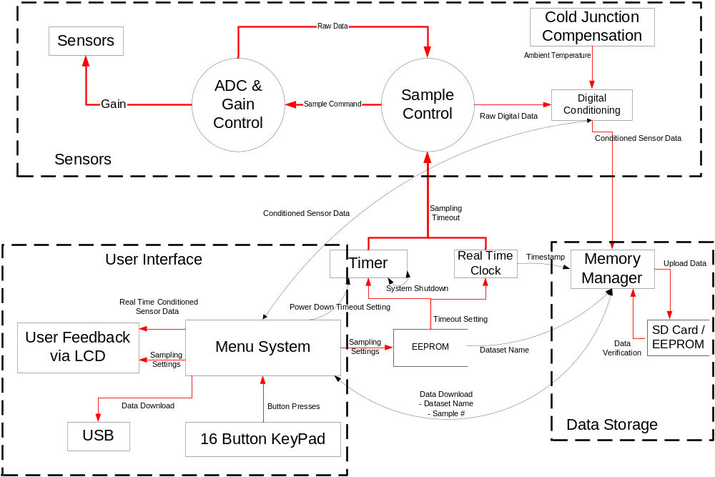

Figure 7 Software Dataflow Diagram for the Datalogger

Data is stored using the 32-bit IEEE-753 floating point format. Also recorded are the date the recording began and a 24-bit timestamp for each set of samples. The data set is retrieved via the USB connection or by placing the SD card into a SD card reader on a PC. A software program on the PC then parses the data set and outputs a file in a comma separated variable (CSV) format. This format was chosen since it can be easily imported by Microsoft Excel and MATLAB.

DISCUSSION

A test case (Figure 8) was set up with a variable DC voltage supply providing current to an 11Ω and 1Ω resistor. A thermocouple was placed onto the heatsink of the 11Ω resistor to measure its temperature.

Approximately 30 seconds of data was captured and the relationship between each variable is plotted in Figure 9. When the voltage across the resistor is 32.5V, current through the 11Ω can be calculated to be 2.96A. This value corresponds to that recorded by the datalogger as shown in Figure 9. The temperature of the resistor can also be seen to increase linearly with energy input. A steady state temperature will be reached when the heat transfer by radiation and convection equal that of the input power.

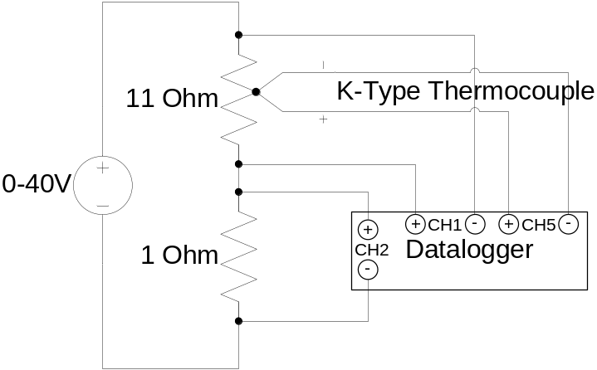

Figure 8 Datalogger test case setup

This datalogger allows relationships between different variables to be established. One application is that it be used for testing and analytical purposes. Several variables could be logged, and once profiled, may provide an insight into how they are related. The measurement of voltage, current and temperature of an 11Ω resistor is one example. More recorded waveforms are presented in Appendix D. Figure D-2 and Figure D-3 demonstrate the precision and accuracy of this datalogger for highly attenuated signals and extreme temperatures respectively.

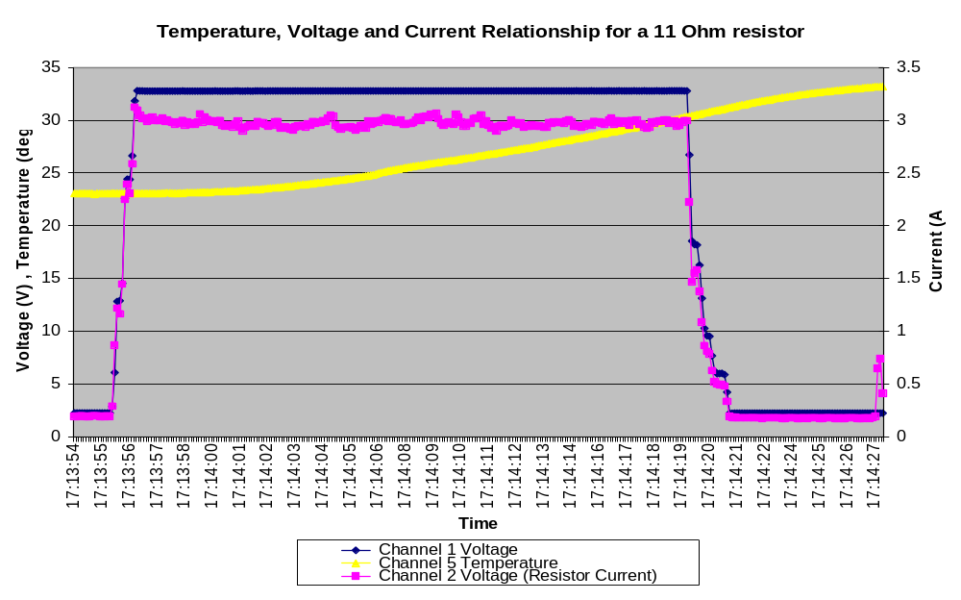
Figure 9 Voltage, current and temperature relationship for an 11Ω resistor

In the example above, 1000 samples were taken over 33 seconds. The maximum sampling rate is approximately 10 milliseconds. Therefore with an oversampling factor of 10, only signals with a maximum frequency component of 10 Hz can be logged precisely. Increasing the number of channels being logged may also limit the maximum sampling rate for each channel. Thus this datalogger is most suited to measuring steady-state variables.

The variability in data was approximately 0.05% for a steady state input. Calibration is required to achieve a high level of accuracy. This can be done either through adjusting the gain coefficients in the software code, or by executing the self calibration routines of the ADC.

Improvements

The central microcontroller used was an 8-bit ATMEGA32 operating at 8 MHz. More features and functionality could have been implemented had a Texas Instruments MSP430 microcontroller been used. The MSP430x2xx family are 16-bit processors which may operate up to 16MHz, their power consumption is also much lower than that of an ATMEGA32 [].

Currently, sampling rates are limited by the microcontroller, not the ADC. By using a faster microcontroller, faster sampling rates can be achieved thereby allowing data containing high frequency components to be logged. However there is usually a trade off between performance and power-consumption.

It would be useful to have a real-time fast Fourier transform (FFT) to display the frequency composition the input signals. However it was decided that real-time FFT performance would be poor due to the memory and speed limitations of an ATMEGA32 and the complexity of calculating an FFT [].

A future design should solely use surface mount components. Surface mount components have lower lead inductances and reduce electrical noise emissions. Some through hole parts were used due to a longer than expected lead time for surface mount components. This change increased the physical size of the board and hence increased production costs.

Other design considerations

A different design approach considered was to implement a digital controller conforming to the IEEE-488. The IEEE-488 is a standard interface between digital controllers and programmable instruments. The IEEE-488 also defines a set of standard instructions that allows a digital controller to retrieve data from an instrument. Error handling, status reporting and defined data formats, all of which are desirable for a controller instrument interface, are also defined [Error: Reference source not found].

This approach was not taken because it is dated [Error: Reference source not found] and compatible instruments were costly and difficult to obtain.

CONCLUSIONS
Using the hardware and software design methodologies described in this report, a fully functional, differential input datalogger has been successfully built. Using a faster microcontroller for a future design would allow extra functionality, such as a real time FFT to be implemented.

The datalogger is suited to measure steady state signals, although signals with frequency components up to 10 Hz can be logged with a precision to within 0.05%. Capable of logging up to 32 channels, the datalogger certainly has many useful practical applications. Whether it is used to monitor environment conditions or operating characteristics of a particular system, the datalogger may provide useful information aiding in decision making or providing results for assessments and understanding.

REFERENCES
This page is intentionally left blank
APPENDICES

DATALOGGER SCHEMATICS

Figure A-10 Datalogger Schematic Overview

Figure A-11 Main Datalogger Board

Figure A-12 Power Supply Circuit

Figure A-13 Instrumentation Amplifier, Anti-Aliasing Filter and Virtual Ground Generator

Figure A-14 User Interface Circuitry


Figure A-15 Memory and Data storage


Figure A-16 Gain and Channel Selector

Figure A-17 Input Filter and Sensor Front-end

Figure A-18 Sensor Card Multiplexer
Figure A-19 Sensor Multiplexer

PCB LAYOUT DESIGN
Figure B-20 Datalogger main control board, top layer

Figure B-21 Datalogger main control board, bottom layer

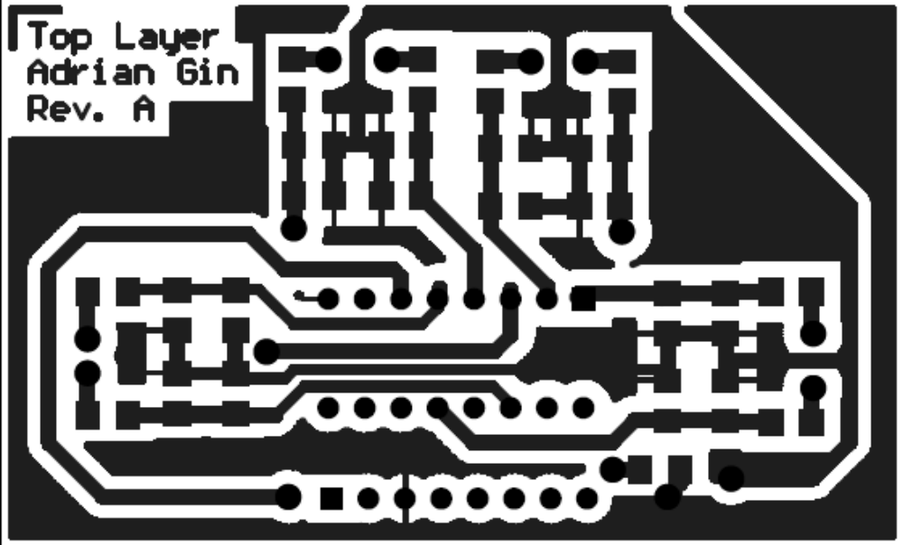
Figure B-22 Sensor card plug-in board, top layer

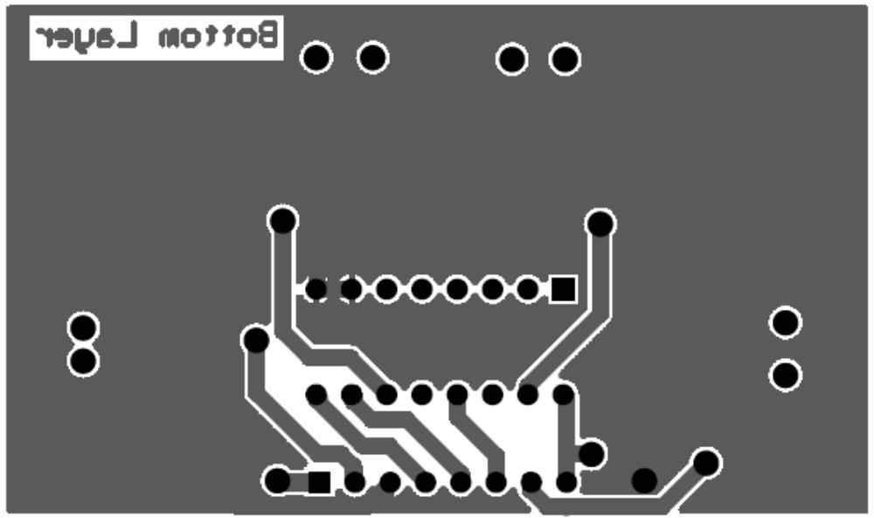
Figure B-23 Sensor Card plug in board, bottom layer

COST LISTING

Table 2 Approximate materials cost
Component | Category | Description | Price  (NZD) | Supplier | Part # | Qty | Cost | Inc.  GST | Cumulative
Misc Electrical Components | Fixed | Passive, Opamp,  Logic IC, Crystal | $40.00 | Various |  | 1 | $40.00 | $45.00 | $45.00
LCD 20X4 with Backlight | User Interface |  | $22.00 | SurplusTronics | QPP020 | 1 | $19.56 | $22.00 | $67.00
SD CARD 512MB | Storage | 512MB | $20.00 | Ascent | 341778 | 1 | $20.00 | $22.50 | $89.50
ATMEGA32 | Semiconductor |  | $5.00 | Soanar | ZA-P101 | 1 | $5.00 | $5.63 | $95.13
FTDI232R | Semiconductor | Reduced Component Count | $7.00 | Dontronics |  | 2 | $14.00 | $15.75 | $110.88
PCB | Fixed | 25c per square inch | $0.25 | University |  | 50 | $12.50 | $14.06 | $124.94
K-Type Thermocouple | Sensor |  | $8.03 | Soanar | QM1283 | 1 | $8.03 | $9.03 | $133.97
USB Cable | Connector | A To B plug cable | $7.68 | Soanar | WC7700 | 1 | $7.68 | $8.64 | $142.61
KEYPAD 16DIGIT | User Interface | KEYPAD 16DIGIT | $7.22 | Soanar | SP0772 | 1 | $7.22 | $8.12 | $150.73
ATMEGA16 | Programming Interface |  | $5.80 | Soanar | ZA-P089 | 1 | $5.80 | $6.53 | $157.26
SD Card Socket | Connector | SD Card Socket | $4.00 | Soanar | PS0024 | 1 | $4.00 | $4.50 | $161.76
USB B Plug | Connector |  | $1.45 | Soanar / Sicom | PS-0920 | 1 | $1.45 | $1.63 | $163.39
DB9 Female Plugs | Programming Interface |  | $0.38 | Soanar / Sicom | PS-0804 | 1 | $0.38 | $0.43 | $163.82
Shipping & (GST) Surplustronics = $5, SoanarPlus, Dontronics = $10 |  |  |  |  |  |  | $43.20 | $25.00
Subtotal |  |  |  |  |  |  | $188.82 | $188.82

ADDITIONAL RECORDED WAVEFORMS

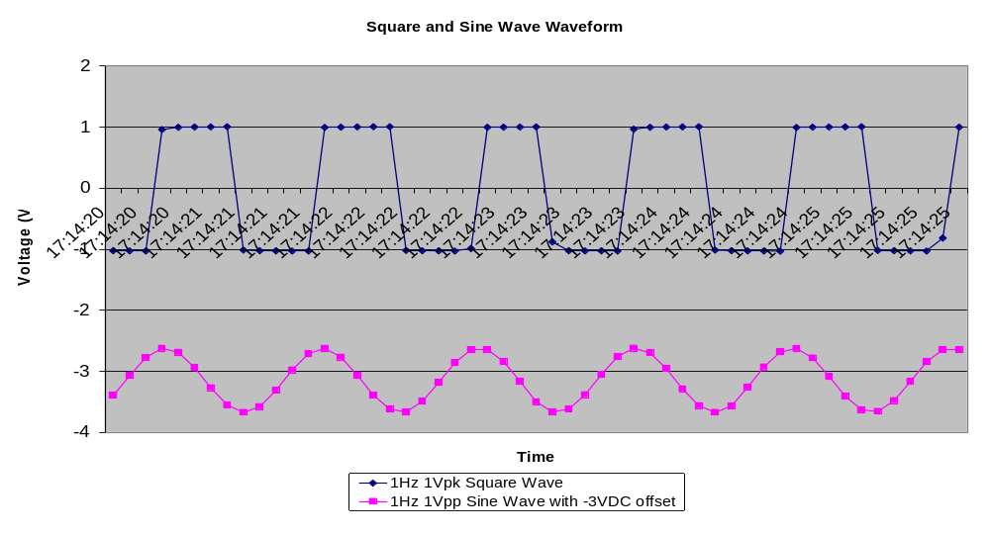
Figure D-1 Square and sine wave recordings

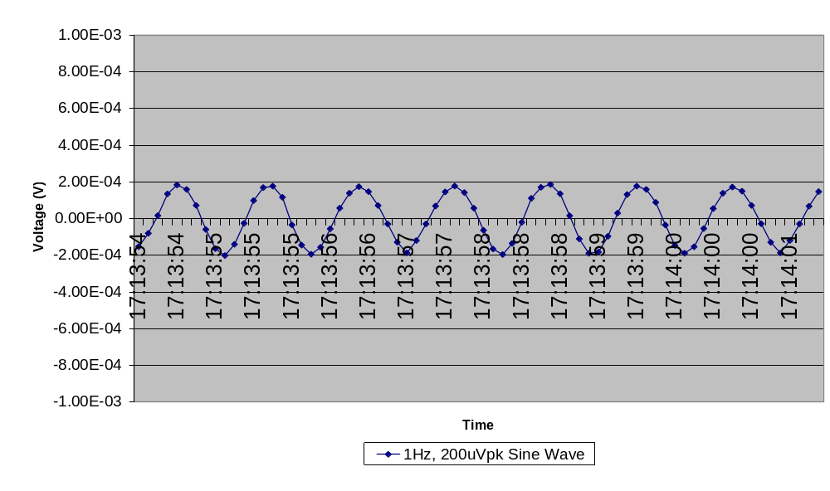
Figure D-2 Small signal performance for a 1Hz 200μV_{PEAK} Sine Wave
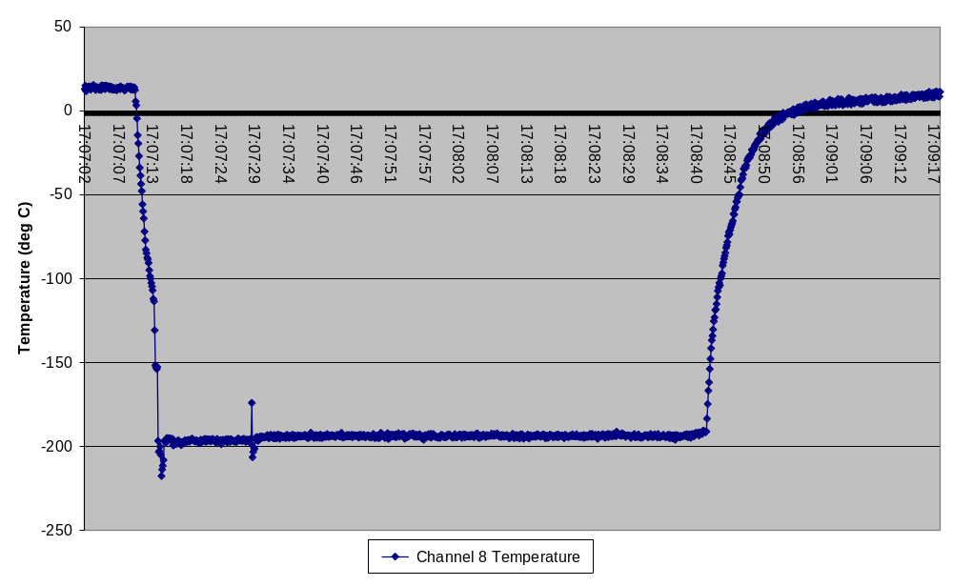
Figure D-3 Temperature of a thermocouple placed in liquid Nitrogen for 85 seconds. The boiling point of liquid nitrogen is -195.8°C
-196 °C

[?] J. Park, S. Mackaym “Practical Data Acquisition for Instrumentation and Control Systems”, Newnes, 2003, pp 120 – 121, 209-217, 234-251.
[?] S. Tumanski, “Principles of Electrical Measurement”, Taylor and Francis, 2006, pp 8, 211, 349-421.
[?] transducer. (2007). In Encyclopædia Britannica. Retrieved September 10, 2007, from Britannica Concise Encyclopedia: http://concise.britannica.com/ebc/article-9073189/transducer
[?] R. Mancini, “Op Amps for Everyone” Design Reference: SLOD600B, Texas Instruments, 2002, pp. 12-1 – 12-23, 4-1 – 4-22.
[?] B. A. Gregory “An Introduction to Electrical Instrumentation and Measurement Systems”, 2nd Ed, The MacMillan Press, 1981. pp 37, 276-278
[?] D. L. Terrell, “Op Amps: Design, Application and Troubleshooting”, 2nd Ed, Butterworth-Heinemann, 1996, pp 405-409
[?] C. Kitchin, L. Counts , “Designer’s Guide to Instrumentation Amplifiers”, 3rd Ed, Analog Devices, 2006, pp 1-9, 5-1 – 5-23.
[?] R. Mancini, “Sensor to ADC – Analog Interface Design”, SLYT015, Texas Instruments, 2000
[?] D. E. Johnson, “Introduction to Filter Theory”, Prentice-Hall Inc, 1976, pp 147-154
[?] Texas Instruments, “Amplifier and Data Conversion Selection Guide”, SLYB115B, 2007, pp. 52-68.
[?] Datalight Inc. “NAND vs. NOR flash”, http://www.windowsfordevices.com/articles/AT6841560808.html, retrieved 5 September 2007.
[?] L.D de Almeida Pereira Zuquim, C.J.N Coelho Jr., A.O. Fernandes, M.P de Oliveira, A.I.Tavares, “An embedded converter from RS232 to Universal Serial Bus”, IEEE Integrated Circuits and Systems Design, 2001, 14th Symposium on.10-15 Sept. 2001 pp 91-96.
[?] J. Axelson, “USB Complete”, 2nd Ed, Lakeview Research, 2001. pp 1-20
[?] I. Sommerville, “Software Engineering”, 6th Ed, Addison-Wesley, 2001, pp 289-305
[?] A. Bainbridge-Smith, “Version Control”, University of Canterbury, ENEL428 Lecture Notes, 2007.
[?] A. Bainbridge-Smith, “Building Software”, University of Canterbury, ENEL428 Lecture Notes, 2007.
[?] D. Budgen, “Software Design”, 2nd Ed, Addison-Wesley, 2003, pp 63-85.
[?] Texas Instruments, “MSP430x2xx Family” User Guide: SLAU144C, Texas Instruments, 2007, pp. 1-6
[?] M. Frigo and S. G. Johnson, "The Design and Implementation of FFTW3," Proceedings of the IEEE 93 (2), 2005, pp 216–231. http://www.fftw.org/

